ACCIDENT ASSESSMENT FORM

|  |  |
| --- | --- |
| **Surname** | **:** |
| **First Name** | **:** |
| **Company** | **:** |
| **Sex** | **:** |
| **Date of Birth** | **:** |
| **Date** | **:** |
| **Onset Time** | **:** |

|  |  |  |  |
| --- | --- | --- | --- |
| PRIMARY SURVEY | | **Time :** | |
| **Airway** | **Clear** | | **Obstructed** |
| **Breathing** | **Spontaneous** | | **Difficulty** |
| **C. Spine** | **Normal** | | **Possible Injury** |
| **Circulation/ Haemorrhage** | **External**  **None/Slight**  **Moderate**  **Severe** | | **Internal**  **Possible** |
| **Disability respond to** | **Alert**  **Visual Stimuli** | | **Pain**  **Unresponsive** |

|  |  |  |
| --- | --- | --- |
| PRIMARY MANAGEMENT | | |
| **Airway** | **Oropharyngeal**  **C/Thyrotomy**  **Oxygen** | **Nasal**  **ET Tube**  **Suction** |
| **Breathing** | **Ventilated** | **Chest Drain** |
| **C. Spine** | **Sand Bags** | **Stiff Neck** |
| **Circulation** | **Cannula Size :**  **Rt…………….** | **Lt. …………….** |
| **IV Fluid** | **Ringers / Saline**  **Colloid** | **Vol. Time**  **……… ….….**  **……… ..……** |

|  |  |  |  |  |  |  |  |  |  |
| --- | --- | --- | --- | --- | --- | --- | --- | --- | --- |
| SECONDARY SURVEY | | | | | | | | | |
| **Eye Opening** | | | **Spontaneous**  **To voice**  **To pain**  **None** | | | | **4**  **3**  **2**  **1** | | |
| **Best Verbal Response** | | | **Oriented**  **Confused**  **Inappropriate**  **Incomprehensible**  **None** | | | | **5**  **4**  **3**  **2**  **1** | | |
| **Motor Response** | | | **Obeys command**  **Localises pain**  **Withdrawal (pain)**  **Flexion (pain)**  **Extension (pain)**  **None** | | | | **6**  **5**  **4**  **3**  **2**  **1** | | |
| **Pupils** | | | **React**  **Constricted**  **Normal**  **None** | | **R**  **R**  **R**  **R** | | **L**  **L**  **L**  **L** | | |
| **Coma Score** | | | **Time : ……… Score : …………….** | | | | | | |
| **Comments** | | |  | | | | | | |
| SECONDARY MANAGEMENT | | | | | | | | | |
| **Analgesia** | | | **Drug** | | | **Dose Time**  **………. ……….**  **………. ……….** | | | |
| **Splinting** | | | **Frac Straps**  **Traction**  **Box** | | | **KED**  **Inflatable**  **Others (specify)** | | | |

|  |  |
| --- | --- |
| **OBSERVATIONS** | **Time :** |
| **Respiratory Rate :** | |
| **Oxygen Saturation (Sa O2) :** | |
| **Blood Pressure :** | |
| **Pulse Rate :** | |

|  |
| --- |
| **EXPOSURE / INJURY** |

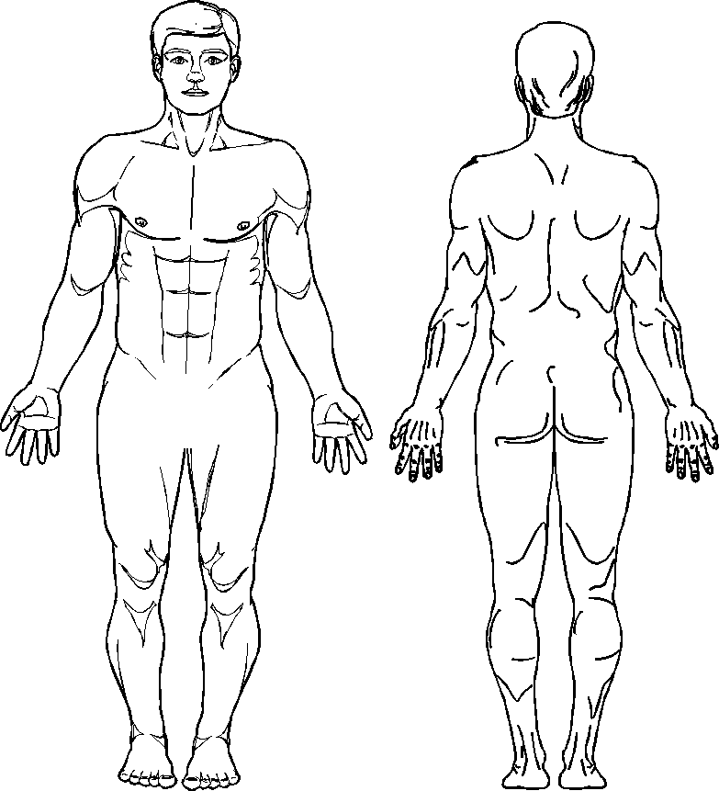

**Notes :**

**C* = Closed Fracture**

**O* = Open Fracture**

**B = Burn (shade the area)**

**F = Foreign Body**

**L = Laceration**

**A = Abrasion**

**E = Eccymosis (bruising)**

PATIENT OBSERVATION RECORD

|  |  |  |  |  |  |  |  |  |  |  |  |  |  |  |  |
| --- | --- | --- | --- | --- | --- | --- | --- | --- | --- | --- | --- | --- | --- | --- | --- |
| Date of Assessment : ……./ ……./ ……. TIME | | | 2) | 3) | 4) | 5) | 6) | 7) | 8) | 9) | 10) | 11) | 12) |  | TREATMENT |
| RESPIRATORY RATE | 10 – 29/min  >29/min  6 – 9/min  1 – 5/min  None | |  |  |  |  |  |  |  |  |  |  |  |  | Drugs givens :  Infusion : |
| SYSTOLIC BLOOD PRESSURE | > 89 mmHg  76 – 89 mmHg  50 – 75 mmHg  1 – 49 mmHg  No BP | |  |  |  |  |  |  |  |  |  |  |  |  |
| PULSE | Beats per Min | |  |  |  |  |  |  |  |  |  |  |  |  |
| OXYGEN SATURATION | % | |  |  |  |  |  |  |  |  |  |  |  |  |
|  |  | |  |  |  |  |  |  |  |  |  |  |  |  |
| GLASGOW COMA SCALE (GCS) | | |  |  |  |  |  |  |  |  |  |  |  |  |
| EYE OPENING | Spontaneous  To voice  To pain  None | 4  3  2  1 |  |  |  |  |  |  |  |  |  |  |  |  |
| VERBAL RESPONSE | Oriented  Confused  Inappropriate Words  Incomprehensible Sounds  None | 5  4  3  2  1 |  |  |  |  |  |  |  |  |  |  |  |  | General Comments |
|  | Obeys Command  Localises Pain  Withdraw (pain)  Flexion (pain)  Extension (pain)  None | 6  5  4  3  2  1 |  |  |  |  |  |  |  |  |  |  |  |  |
|  | Coma Scale Score |  |  |  |  |  |  |  |  |  |  |  |  |  |
|  |  |  |  |  |  |  |  |  |  |  |  |  |  |  |